**http://www.ats.ucla.edu/stat/spss/faq/compreg2.htm**

**SPSS FAQ  
How can I compare regression coefficients between two groups?**

Sometimes your research hypothesis may predict that the size of a regression coefficient should be bigger for one group than for another.  For example, you might believe that the regression coefficient of **height** predicting **weight** would be higher for men than for women.  Below, we have a data file with 10 fictional females and 10 fictional males, along with their **height** in inches and their **weight** in pounds.

**data list free**

**/ id * gender (A8) height * weight.**

**begin data.**

**1 F 56 117**

**2 F 60 125**

**3 F 64 133**

**4 F 68 141**

**5 F 72 149**

**6 F 54 109**

**7 F 62 128**

**8 F 65 131**

**9 F 65 131**

**10 F 70 145**

**11 M 64 211**

**12 M 68 223**

**13 M 72 235**

**14 M 76 247**

**15 M 80 259**

**16 M 62 201**

**17 M 69 228**

**18 M 74 245**

**19 M 75 241**

**20 M 82 269**

**end data.**

**execute.**

We analyzed their data separately using the **regression** commands below.  Note that we have to do two regressions, one with the data for females only and one with the data for males only.  We can use the **split file** command to split the data file by **gender** and then run the regression.  The parameter estimates (coefficients) for females and males are shown below, and the results do seem to suggest that **height** is a stronger predictor of **weight** for males (3.18) than for females (2.09).

**sort cases by gender.**

**split file by gender.**

**regression**

**/dep weight**

**/method = enter height.**

**split file off.**

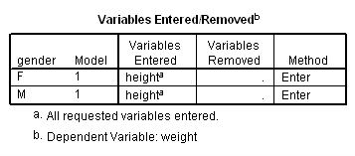

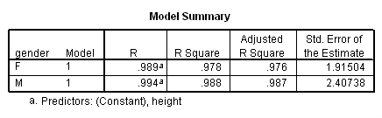

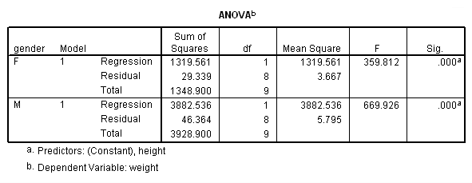

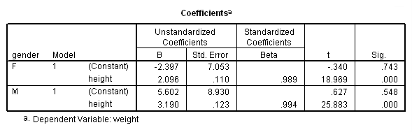

We can compare the regression coefficients of males with females to test the null hypothesis Ho: **Bf** = **Bm**, where **Bf** is the regression coefficient for females, and **Bm** is the regression coefficient for males.  To do this analysis, we first make a dummy variable called **female** that is coded 1 for female and 0 for male, and a variable **femht** that is the product of **female** and **height**.  We then use **female**, **height** and **femht** as predictors in the regression equation.

**split file off.**

**compute female = 0.**

**if gender = "F" female = 1.**

**compute femht = female*height.**

**execute.**

**regression**

**/dep weight**

**/method = enter female height femht.**

The output is shown below.

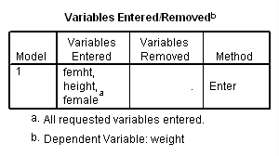

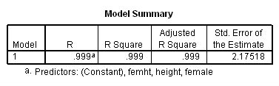

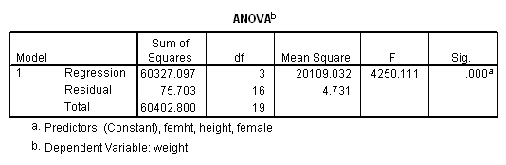

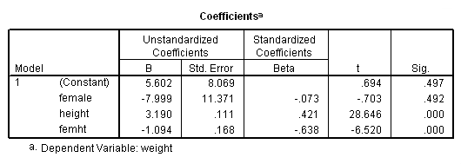

The term **femht** tests the null hypothesis Ho: **Bf** = **Bm**. The T value is -6.52 and is significant, indicating that the regression coefficient **Bf** is significantly different from **Bm**.

Let's look at the parameter estimates to get a better understanding of what they mean and how they are interpreted.    
First, recall that our dummy variable **female** is 1 if female and 0 if male; therefore, males are the omitted group.  This is needed for proper interpretation of the estimates.

|  |
| --- |
| **Parameter**  **Variable Estimate**  **INTERCEP 5.601677 : This is the intercept for the males (omitted group)**  **This corresponds to the intercept for males in**  **the separate groups analysis.**  **FEMALE -7.999147 : Intercept Females - Intercept males**  **This corresponds to differences of the**  **intercepts from the separate groups analysis.**  **and is indeed -2.397470040 - 5.601677149**  **HEIGHT 3.189727 : Slope for males (omitted group), i.e. Bm.**  **FEMHT -1.093855 : Slope for females - Slope for males**  **(i.e. Bf - Bm).**  **From the separate groups, this is indeed**  **2.095872170 - 3.189727463 .** |

It is also possible to run such an analysis using **glm**, using syntax like that below.  Note that other statistical packages, such as SAS and Stata, omit the group of the dummy variable that is coded as zero.  However, SPSS omits the group coded as one.  Therefore, when you compare the output from the different packages, the results seem to be different.  To make the SPSS results match those from other packages, you need to create a new variable that has the opposite coding (i.e., switching the zeros and ones).  We do this with the **male** variable.  We do not know of an option in SPSS **glm** to easily change which group is the omitted group.  (Please note that you can use the **contrast** subcommand to get the contrast coefficient for **female** using 0 as the reference group; however, the coding of **female** in the interaction is such that 1 is used as the reference group, so the use of the **contrast** subcommand is not very helpful in this situation.)

**compute male = not female.**

**glm weight by male with height**

**/design = male height male by height**

**/print = parameter.**

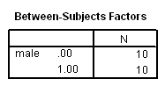

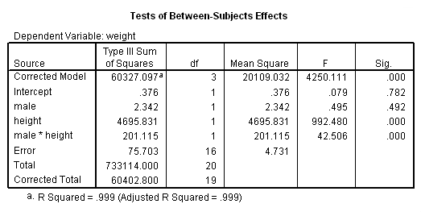

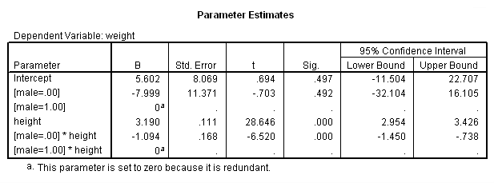

As you see, the **glm** output corresponds to the output obtained by **regression**.  The parameter estimates appear at the end of the **glm** output.  They also correspond to the output from **regression**.

[How to cite this page](http://www.ats.ucla.edu/stat/mult_pkg/faq/general/citingats.htm)

[Report an error on this page or leave a comment](http://www.ats.ucla.edu/stat/apps/codetrack/errdirect.php)

The content of this web site should not be construed as an endorsement of any particular web site, book, or software product by the University of California.

**IDRE Research Technology Group**

[**High Performance Computing**](https://idre.ucla.edu/hpc)

[**Statistical Computing**](https://idre.ucla.edu/stats)

[**GIS and Visualization**](https://idre.ucla.edu/gis-visualization)

* [High Performance Computing](https://idre.ucla.edu/hpc)
* [GIS](https://idre.ucla.edu/gis)
* [Statistical Computing](https://idre.ucla.edu/stats)
* [Hoffman2 Cluster](https://idre.ucla.edu/hoffman2)
* [Mapshare](https://idre.ucla.edu/mapshare)
* [Classes](https://idre.ucla.edu/events/classes)
* [Hoffman2 Account Application](https://idre.ucla.edu/hoffman2/getting-started)
* [Visualization](https://idre.ucla.edu/visualization)
* [Conferences](https://idre.ucla.edu/events/conferences)
* [Hoffman2 Usage Statistics](https://idre.ucla.edu/hoffman2/cluster-statistics)
* [3D Modeling](https://idre.ucla.edu/3d-modeling)
* [Reading Materials](https://idre.ucla.edu/reading-materials)
* [UC Grid Portal](http://portal.ucgrid.org/)
* [Technology Sandbox](https://idre.ucla.edu/technology-sandbox)
* [IDRE Listserv](http://lists.ucla.edu/cgi-bin/mailman/listinfo/idremailinglist)
* [UCLA Grid Portal](http://grid.ucla.edu/)
* [Tech Sandbox Access](https://idre.ucla.edu/gis-visualization/sandbox-access)
* [IDRE Resources](https://idre.ucla.edu/resources)
* [Shared Cluster & Storage](https://idre.ucla.edu/hpc/shared-cluster-program)
* [Data Centers](https://idre.ucla.edu/data-centers)
* [Social Sciences Data Archive](http://dataarchives.ss.ucla.edu/)
* [About IDRE](https://idre.ucla.edu/about)
* [About](https://idre.ucla.edu/about)
* [Contact](https://idre.ucla.edu/contact)
* [News](https://idre.ucla.edu/news)
* [Events](https://idre.ucla.edu/events)
* [Our Experts](https://idre.ucla.edu/experts)
* © 2014 UC Regents
* [Terms of Use & Privacy Policy](http://www.ucla.edu/terms-of-use/)